**Part 1: News App**

Created a login page with username and password.

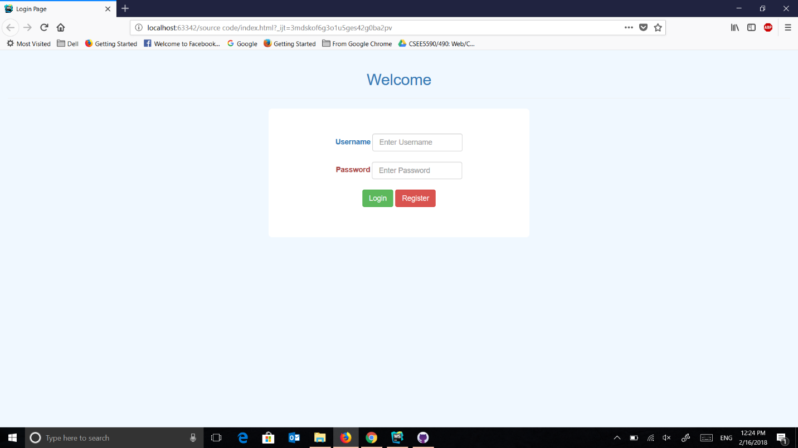

If username and password doesn't match, it will ask for registration

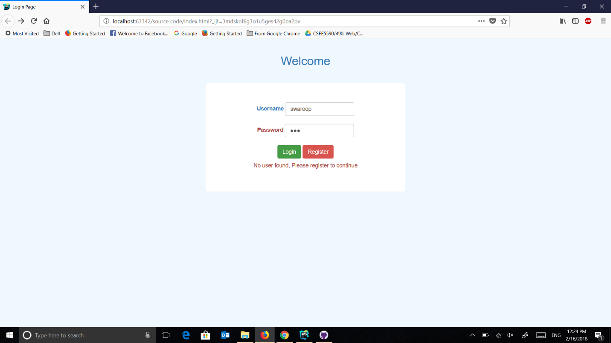

Registration Page

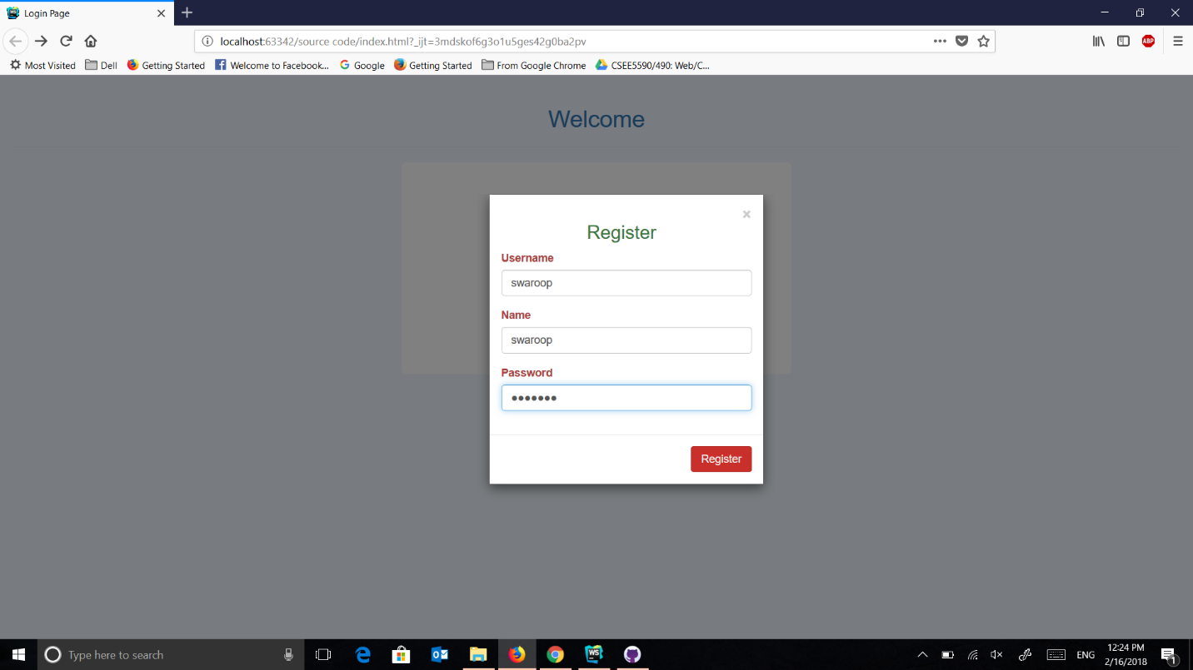

After Registration and signing in, it takes to the home page. which contains search bar to search a topic and dropdown for different news sources.

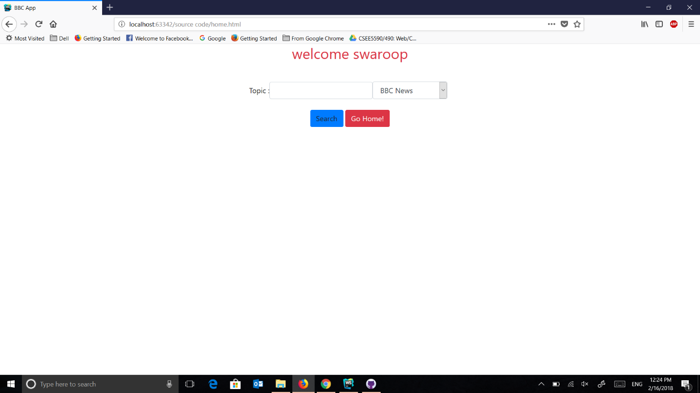

If we search without topic but with source, it will show the top news from the source

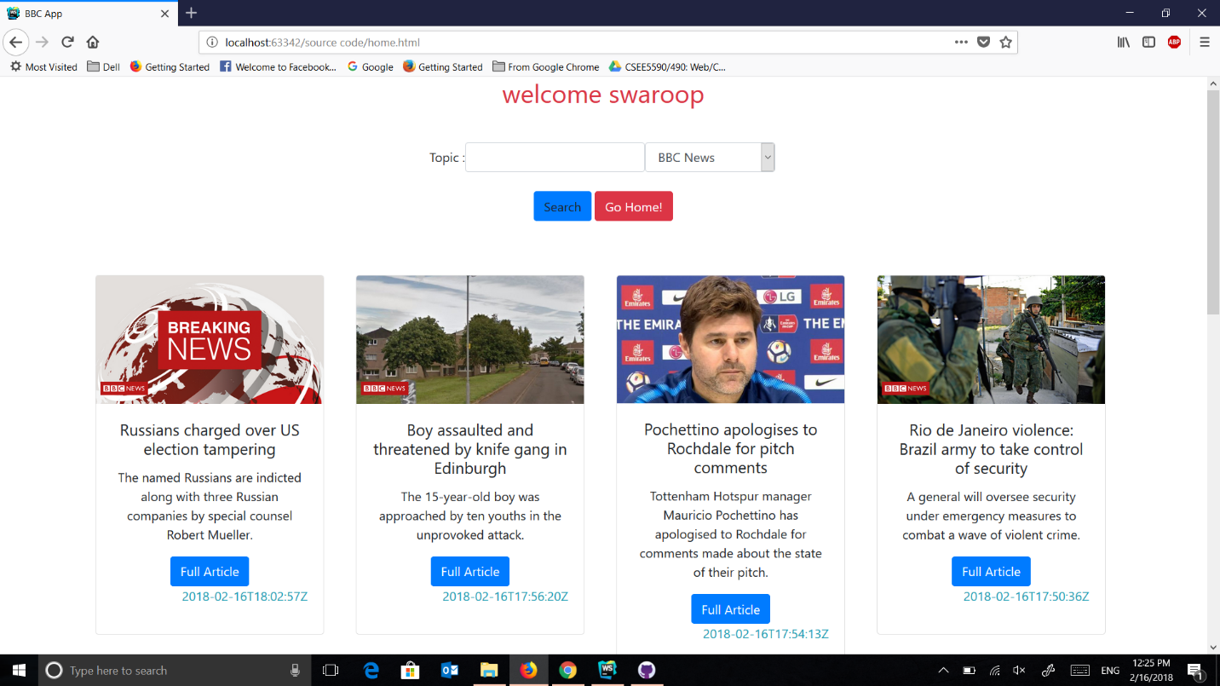

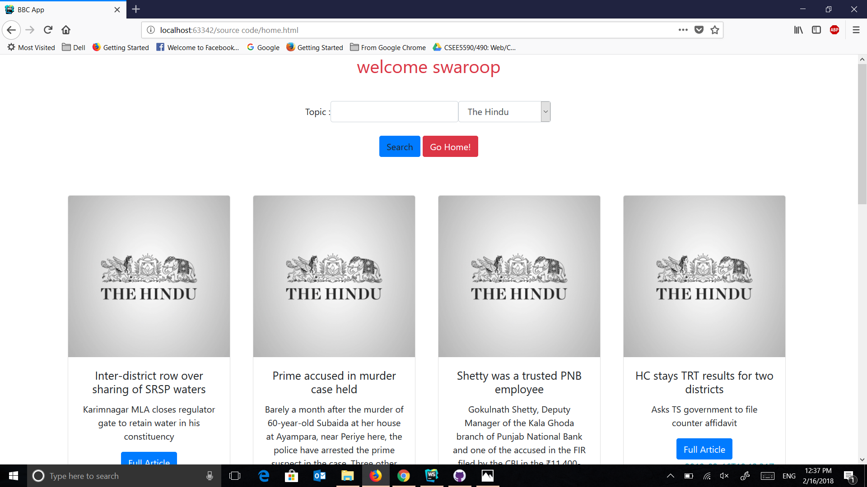

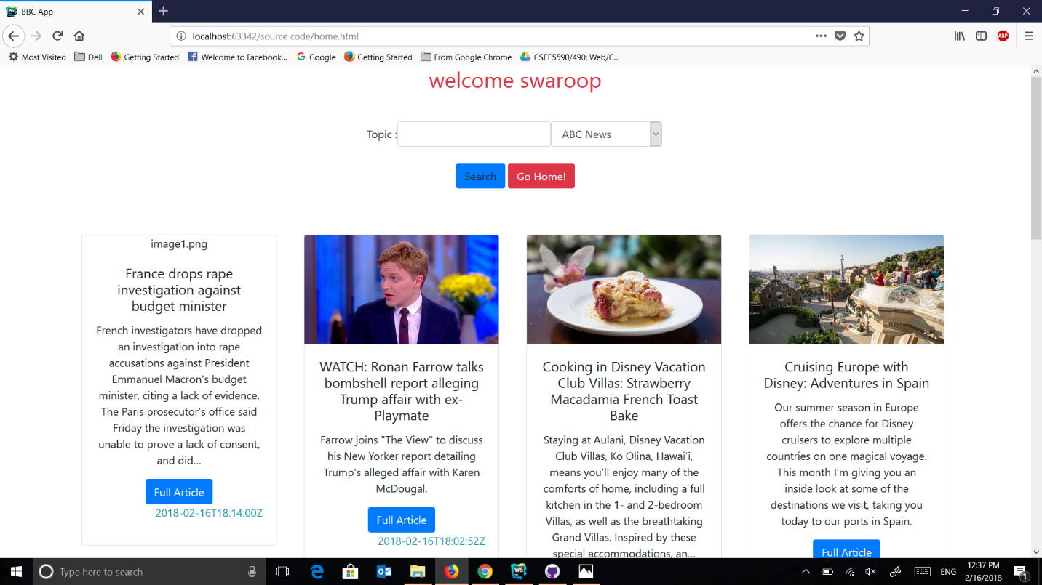

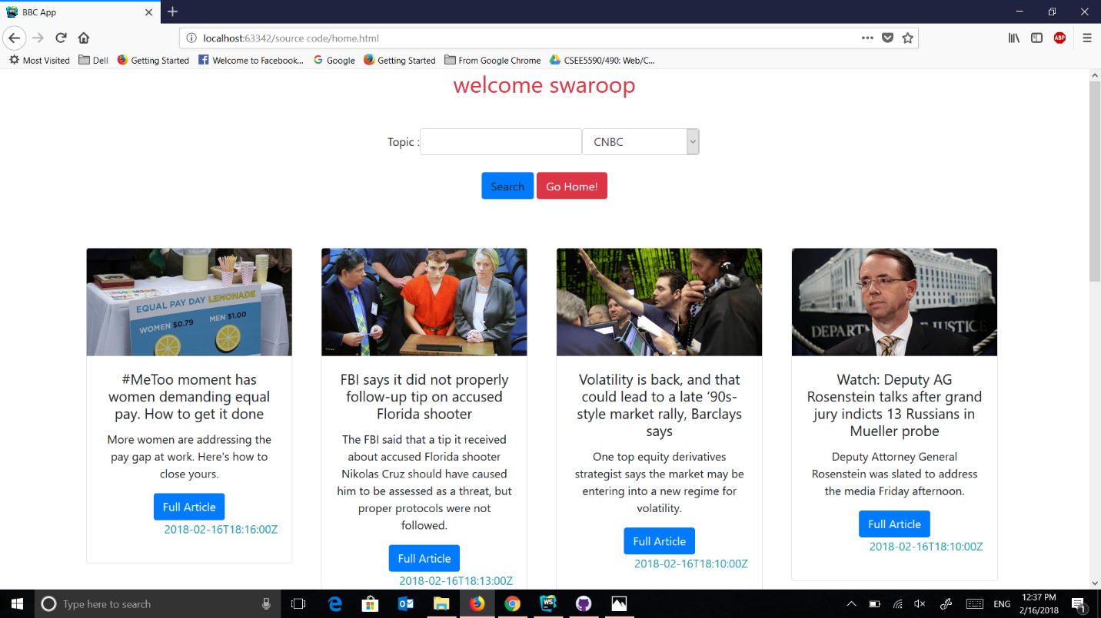

If you click on full article it open new tab with the full content of the article.

If we search for the topic and source

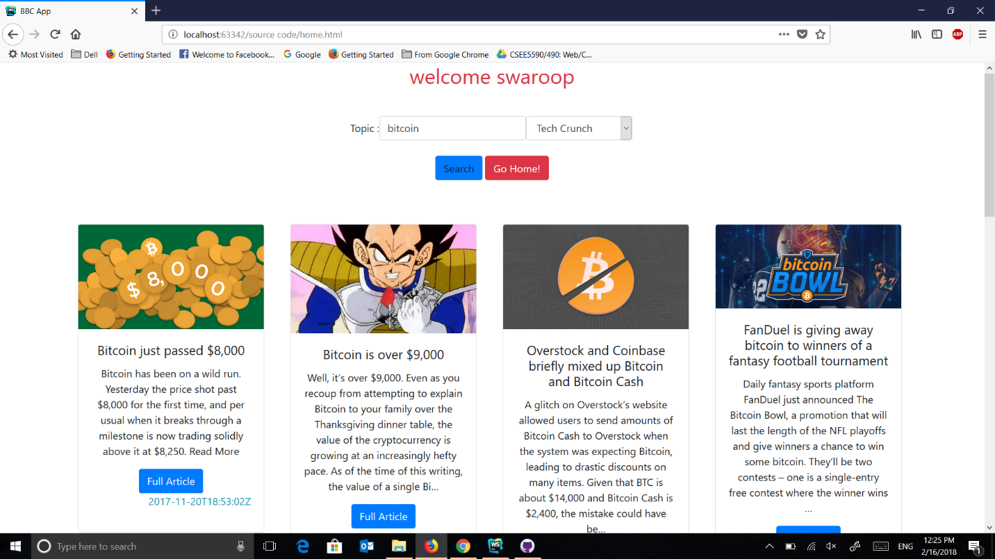

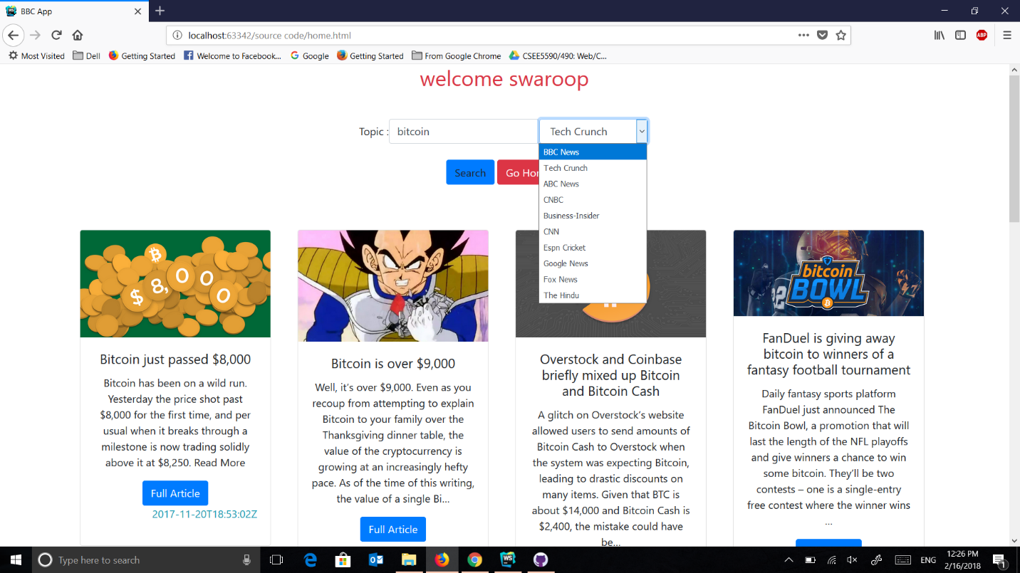

**Part 2: Tie-Toe Game**

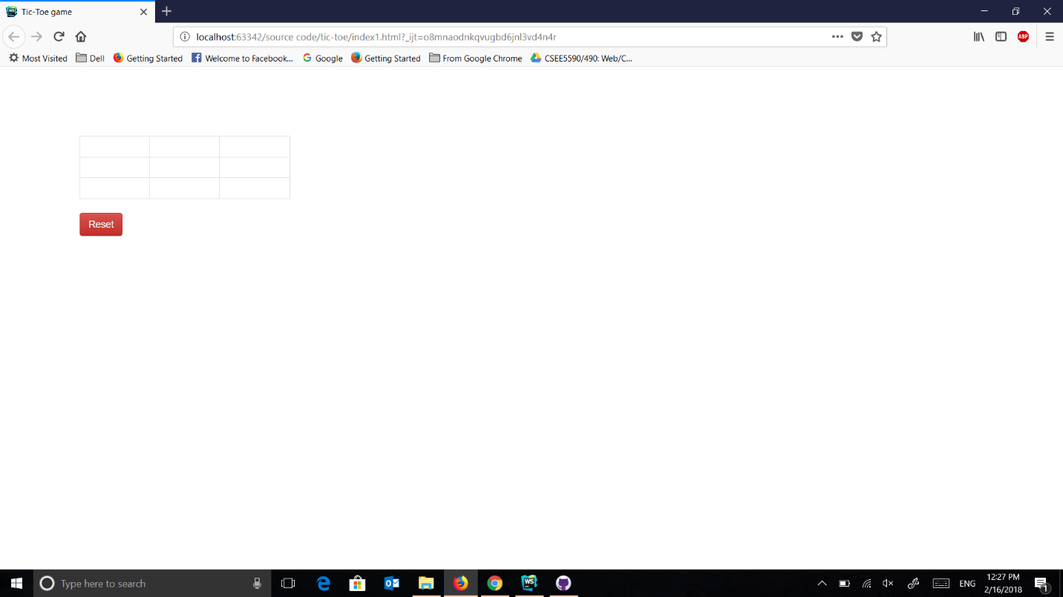

the first player is distinguished by X and the second player by O

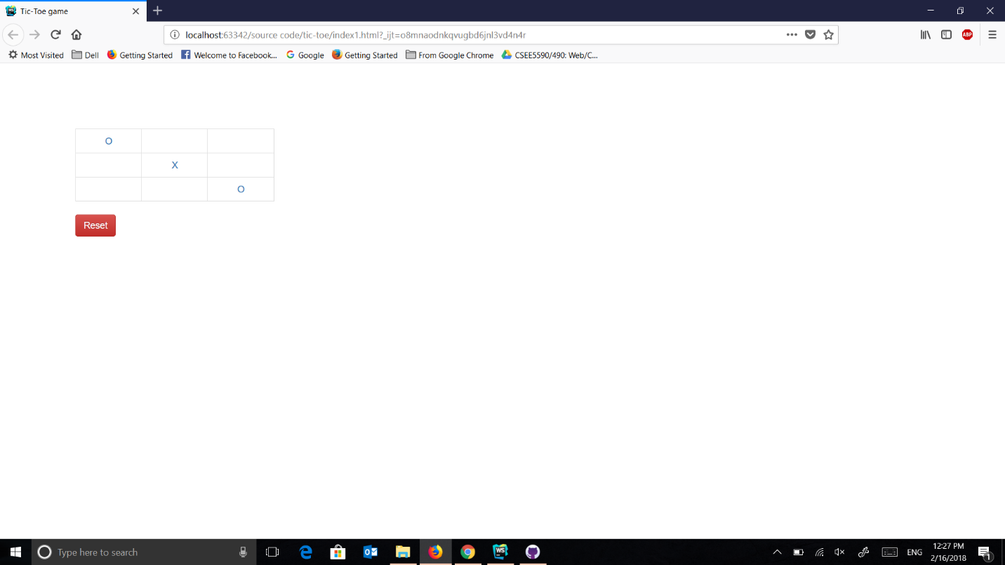

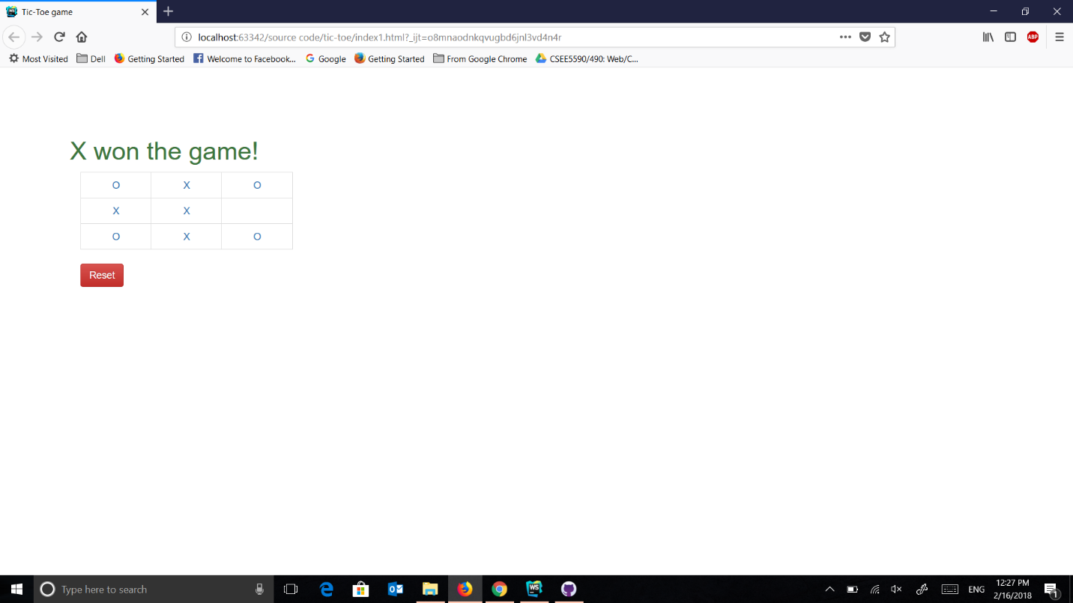

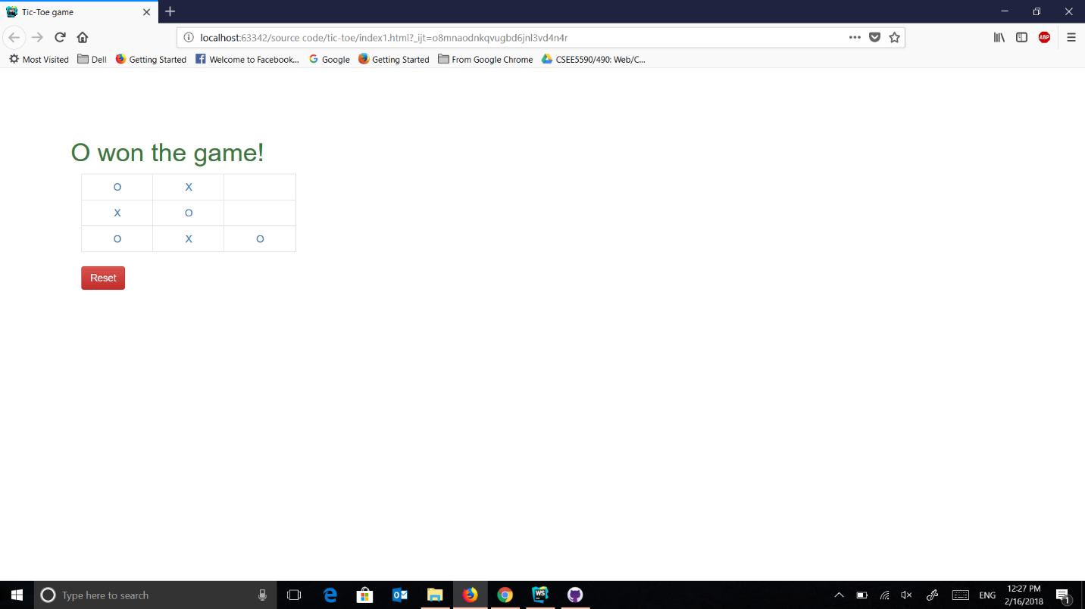

**Code Snippet:**

**var *loginid*** = ***localStorage***.getItem(**"resid"**);  
***console***.log(***loginid***);  
$(**"#page"**).text( **"welcome "** +***loginid***);  
  
  
**function** *respone*(source,topic) {  
  
 **var** xhhtp = **new *XMLHttpRequest***();  
 xhhtp.open(**'GET'**,**"https://newsapi.org/v2/everything?q="**+topic+**"&sources="**+source+**"&apiKey=b5468b9937314c37ae472c8d30430664"**, **false**);  
 xhhtp.send();  
 **return** xhhtp;  
}  
  
**function** *showdata*(news) {  
  
 ***console***.log(news.articles);  
 $(**"#card1"**).show();  
 $(**"#news1"**).text(news.articles[0].title);  
 $(**"#news11"**).text(news.articles[0].description);  
 $(**"#news111"**).attr(**"href"**,news.articles[0].**url**);  
 $(**"#image1"**).attr(**"src"**,news.articles[0].urlToImage);  
 $(**"#time1"**).text(news.articles[0].publishedAt);  
 $(**"#card2"**).show();  
 $(**"#news2"**).text(news.articles[1].title);  
 $(**"#news21"**).text(news.articles[1].description);  
 $(**"#news211"**).attr(**"href"**,news.articles[1].**url**);  
 $(**"#image2"**).attr(**"src"**,news.articles[1].urlToImage);  
 $(**"#time2"**).text(news.articles[1].publishedAt);  
 $(**"#card3"**).show();  
 $(**"#news3"**).text(news.articles[2].title);  
 $(**"#news31"**).text(news.articles[2].description);  
 $(**"#news311"**).attr(**"href"**,news.articles[2].**url**);  
 $(**"#image3"**).attr(**"src"**,news.articles[2].urlToImage);  
 $(**"#time3"**).text(news.articles[2].publishedAt);  
 $(**"#card4"**).show();  
 $(**"#news4"**).text(news.articles[3].title);  
 $(**"#news41"**).text(news.articles[3].description);  
 $(**"#news411"**).attr(**"href"**,news.articles[3].**url**);  
 $(**"#image4"**).attr(**"src"**,news.articles[3].urlToImage);  
 $(**"#time4"**).text(news.articles[3].publishedAt);  
 $(**"#card5"**).show();  
 $(**"#news5"**).text(news.articles[4].title);  
 $(**"#news51"**).text(news.articles[4].description);  
 $(**"#news511"**).attr(**"href"**,news.articles[4].**url**);  
 $(**"#image5"**).attr(**"src"**,news.articles[4].urlToImage);  
 $(**"#time5"**).text(news.articles[4].publishedAt);  
 $(**"#card6"**).show();  
 $(**"#news6"**).text(news.articles[5].title);  
 $(**"#news61"**).text(news.articles[5].description);  
 $(**"#news611"**).attr(**"href"**,news.articles[5].**url**);  
 $(**"#image6"**).attr(**"src"**,news.articles[5].urlToImage);  
 $(**"#time6"**).text(news.articles[5].publishedAt);  
 $(**"#card7"**).show();  
 $(**"#news7"**).text(news.articles[6].title);  
 $(**"#news71"**).text(news.articles[6].description);  
 $(**"#news711"**).attr(**"href"**,news.articles[6].**url**);  
 $(**"#image7"**).attr(**"src"**,news.articles[6].urlToImage);  
 $(**"#time7"**).text(news.articles[6].publishedAt);  
 $(**"#card8"**).show();

$(**"#news8"**).text(news.articles[7].title);  
 $(**"#news81"**).text(news.articles[7].description);  
 $(**"#news811"**).attr(**"href"**,news.articles[7].**url**);  
 $(**"#image8"**).attr(**"src"**,news.articles[7].urlToImage);  
 $(**"#time8"**).text(news.articles[7].publishedAt);  
}  
  
$(***document***).ready(**function** () {  
  
 $(**"#search"**).click(**function** () {  
  
 **topic** = $(**"#topic"**).val();  
 **source**= $(**"#source"**).val();  
 ***console***.log(**source**);  
 ***console***.log(**topic**);  
 **resp** = *respone*(**source**,**topic**);  
 **if** (**resp**.status == 200){  
 *showdata*(***JSON***.parse(**resp**.responseText));  
 ***console***.log(**"success"**);  
 }**else**{  
 ***console***.log(**"not find"**);  
  
 } })});

**Tic-Toe Game:**

var app = angular.module('app1', ['ng']);

(function() {

var Board1 = (function(){

var SIZE1, NOUGHT1, PLAYER_MARKERS1,EMPTY1, Cell1, CROSS1;

SIZE1 = 3;

CROSS1 = 'X';

EMPTY1 = ' ';

NOUGHT1 = 'O';

PLAYER_MARKERS1 = [NOUGHT1, CROSS1];

Cell1 = (function() {

function Cell1(marker){

this.marker1 = marker;

this.winning1 = false;

}

Cell1.prototype.mark1 = function(marker) {

this.marker = marker1;

}

Cell1.prototype.hasBeenPlayed1 = function() {

return this.marker != EMPTY;

}

return Cell1;

})();

function Board1() {

this.reset1();

}

Board.prototype1.reset = function(){

this.currentPlayer1 = 0;

this.grid1 = [];

this.won1 = false;

this.gameGoingOn1 = true;

for(var i=0; i < SIZE1; i++) {

var row1 = [];

for(var j=0; j < SIZE1; j++) {

row1.push(new Cell1(EMPTY));

}

this.grid.push(row1);

}

return this.grid1;

};

Board.prototype1._checkRow = function(rowIndex) {

var numberOfNoughts1 = 0;

var numberOfCrosses1= 0;

for(var columnIndex = 0; columnIndex < SIZE1; columnIndex++) {

var cell1 = this.grid1[rowIndex];

cell1 = cell1[columnIndex];

var cellMarker1 = cell1.marker;

if(cellMarker1 == EMPTY) {

return false;

}

if(cellMarker1 == NOUGHT1) {

numberOfNoughts1++;

} else if(cellMarker1 == CROSS1) {

numberOfCrosses++;

}

}

if(numberOfNoughts1 == SIZE) {

return NOUGHT1;

} else if(numberOfCrosses1 == SIZE) {

return CROSS1;

}

};

Board.prototype1._checkColumn = function(columnIndex) {

var numberOfNoughts1 = 0;

var numberOfCrosses1 = 0;

for(var rowIndex1 = 0; rowIndex < SIZE; rowIndex++) {

var cell1 = this.grid[rowIndex][columnIndex];

var cellMarker1 = cell.marker;

if(cellMarker1 == EMPTY) {

return false;

}

if(cellMarker1 == NOUGHT) {

numberOfNoughts1++;

} else if(cellMarker1 == CROSS) {

numberOfCrosses1++;

}

}

if(numberOfNoughts1 == SIZE) {

return NOUGHT1;

} else if(numberOfCrosses1 == SIZE) {

return CROSS1;

}

}

Board.prototype1._checkDiagonal1 = function() {

var numberOfNoughts1 = 0;

var numberOfCrosses1 = 0;

for(var i = 0; i<SIZE; i++) {

var cellMarker1 = this.grid1[i][i].marker;

if(cellMarker1 == EMPTY) {

return false;

}

if(cellMarker1 == NOUGHT) {

numberOfNoughts1++;

} else if(cellMarker1 == CROSS) {

numberOfCrosses1++;

}

}

if(numberOfNoughts1== SIZE) {

return NOUGHT1;

} else if(numberOfCrosses1 == SIZE) {

return CROSS1;

}

}

Board.prototype1._checkDiagonal2 = function() {

var numberOfNoughts1 = 0;

var numberOfCrosses1 = 0;

for(var i = 0; i<SIZE1; i++) {

var cellMarker1 = this.grid1[i][SIZE-i-1].marker;

if(cellMarker1 == EMPTY) {

return false;

}

if(cellMarker1 == NOUGHT) {

numberOfNoughts1++;

} else if(cellMarker1 == CROSS) {

numberOfCrosses1++;

}

}

if(numberOfNoughts1 == SIZE) {

return NOUGHT1;

} else if(numberOfCrosses1 == SIZE) {

return CROSS1;

}

}

Board.prototype1._setWinner = function(marker) {

this.won1 = true;

this.winning_marker1 = marker;

this.gameGoingOn1 = false;

};

Board.prototype1._markWinnerRow = function(rowIndex) {

for(var i = 0; i<SIZE1; i++) {

this.grid[rowIndex][i].winning1 = true;

}

}

Board.prototype1._markWinnerColumn = function(columnIndex) {

for(var i = 0; i<SIZE1; i++) {

this.grid[i][columnIndex].winning1 = true;

}

}

Board.prototype1._markWinnerDiagonal1 = function() {

for(var i = 0; i<SIZE1; i++) {

this.grid1[i][i].winning1 = true;

}

}

Board.prototype1._markWinnerDiagonal2 = function() {

for(var i = 0; i<SIZE1; i++) {

this.grid[i][SIZE1-i-1].winning1 = true;

}

}

Board.prototype1.checkWinner = function() {

var rowIndex1 = 0;

var columnIndex1 = 0;

var diagonal1 = 0;

var diagonal2 = 0;

for(rowIndex=0; rowIndex < SIZE1; rowIndex++) {

var val1 = this._checkRow(rowIndex1);

if(val1) {

this._setWinner1(val1);

this._markWinnerRow1(rowIndex1);

}

}

for(columnIndex = 0; columnIndex < SIZE1; columnIndex++) {

val2 = this._checkColumn(columnIndex);

if(val2) {

this._setWinner(val2);

this._markWinnerColumn(columnIndex);

}

}

val3 = this._checkDiagonal1();

if(val3) {

this._setWinner(val3);

this._markWinnerDiagonal3();

}

val4 = this._checkDiagonal2();

if(val4) {

this._setWinner(val4);

this._markWinnerDiagonal2();

}

};

Board.prototype1.playCell = function(cell) {

if(!(this.gameGoingOn)) {

return;

}

if(cell.hasBeenPlayed()) {

return;

}

cell.mark1(this.currentPlayerMarker1());

this.checkWinner1();

this.switchPlayer1();

};

Board.prototype1.currentPlayerMarker = function() {

return PLAYER_MARKERS[this.currentPlayer];

}

Board.prototype1.switchPlayer = function() {

this.currentPlayer = 1 - this.currentPlayer;

}

return Board1;

})();

angular.module('app1').factory('Board1', function(){

return Board1;

});

}).call(this);

app1.controller('BoardCtrl1', function($scope, Board){

$scope.board = new Board1;

});